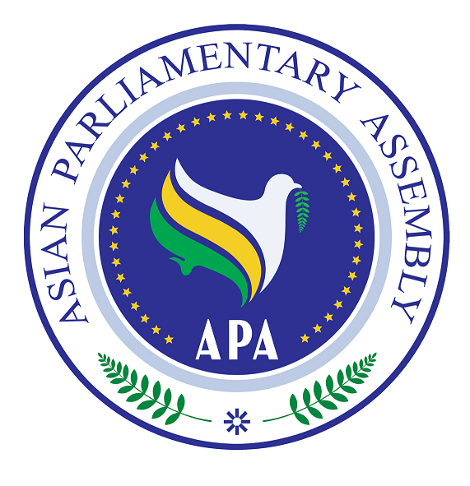

APA/Res/ 2009/02
10 December 2009

Resolution on
Violations of International Humanitarian Law
In the Palestine and the War Crimes
Committed By the Zionist Regime in Gaza

We, the Members of the Asian Parliamentary Assembly,

Inspired by the Principles and objectives enshrined in the APA Charter and the relevant APA resolutions;

Committed to contribute to the promotion of peace and security at regional and global levels on the basis of justice and the rule of law;

Deeply Concerned about the grave humanitarian crisis in Palestine and particularly in Quds and Gaza;
Expressing anxiety over the continuing occupation of the Palestinian territories and the disruption of supplies, food, and medicine intended for its population;
Convinced that illegal acts of excavation under the holy Al-Aghsa mosque and the construction of settlements by the Zionist regime are conducive to further violations of human rights of the Palestinian people;
Recalling APA Resolution on Major Issues of Peace and Security in Asia (APA/Res/2008/06, 29 November 2008);

Welcoming the report of the APA Secretary-General on the visit by APA Troika to countries neighboring Palestine to explore ways and means of channeling humanitarian aids to the people in Gaza (SG/Rep/2009/04, 7 February 2009);

Taking Note of the Report of the United Nations Fact Finding Mission on the Gaza Conflict (A/HRC/12/48, 15 September 2009) and the Resolution of the United Nations General Assembly on the Report of the Human Rights Council (A/64/53/add.1, 16 October 2009);

- Deplore all violations of international law which threaten international peace and security including all acts of terrorism and organized crimes; violations of human rights committed by the Israeli occupying forces.

- Condemn deliberate violations of international humanitarian law by the Israeli occupying forces in Gaza, as partly reported in the Report of the United Nations Fact Finding Mission on the Gaza Conflict which amounts to grave breaches of the Fourth Geneva Convention.

- Underscore the grave breaches of the Geneva Conventions and acts raising individual criminal responsibility under international criminal law and remind the duty imposed by the Geneva Conventions on all High Contracting Parties to search for and bring before their courts those responsible for these violations.

- Encourage all members of the international community to put pressure on the Zionist occupying regime to immediately cease the Gaza siege and let the Palestinian people resume their normal life and begin reconstruction of the damaged areas.

- Call upon the Zionist regime, the occupying power, to withdraw from all the occupied territories including al-Guds al-Sharif, Gaza Strip and the West Bank, the Golan Hights, and Shaba lands, and to release all the Palestinian prisoners including the Members of the Palestinian Parliament; dismantle all the settlements as well as the entire separating wall, and all the checkpoints in the occupied Palestinian lands; and put an end to its policies of confiscating Palestinian lands.
- Call Upon all members of the United Nations as well as all regional and international organizations concerned, particularly the United Nations Security Council and the International Criminal Court to address, under the UN Charter and the Rome Statute, the crimes against humanity and the war crimes committed in Gaza Strip which threaten the international peace and security.

